**Topic: Reducing Balance on Loans**

Time: 45 mins Marks: /45 marks

**Calculator Assumed**



**Question One: [2, 2, 2: 6 marks]**

Nigella has a loan of $10 000 which is at 5.9% p.a interest compounding monthly. She is making $100 monthly repayments. Nigella is using her calculator to predict the amount she will have owing at the start of each month for the first twelve months. The graph below depicts that.

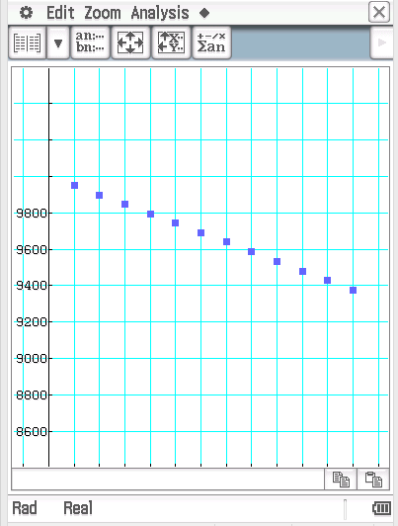

Consider the graphs on the next page. Each graph depicts the balancing owing on the loan at the start of each month for the first twelve months of the loan.

a) Which of the graphs depict the effect of increasing the repayment to $300 per month on the balance at the start of each month?

b) Which of the graphs depict the effect of decreasing the interest rate to 3% p.a but keeping the monthly repayments at $100 per month, on the balance at the start of each month?

c) Which of the graphs below depict the effect of decreasing the interest rate to 3% p.a and reducing the monthly repayments to $300 per month, on the balance at the start of each month?

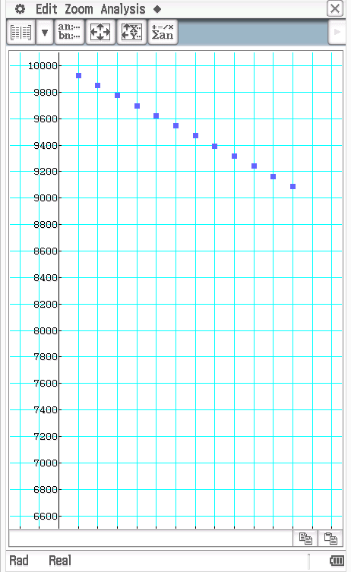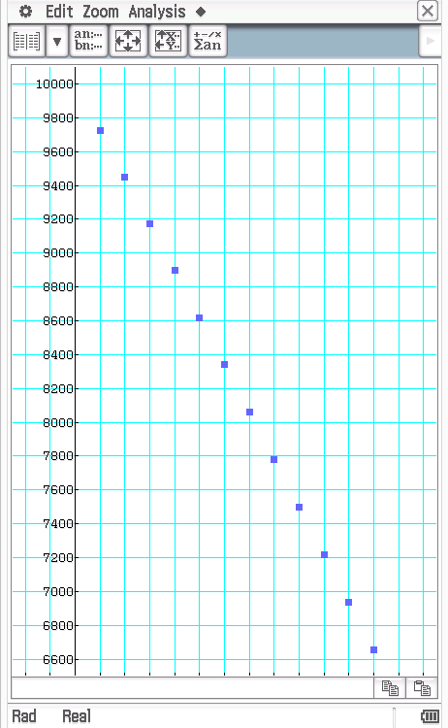Graph A Graph B

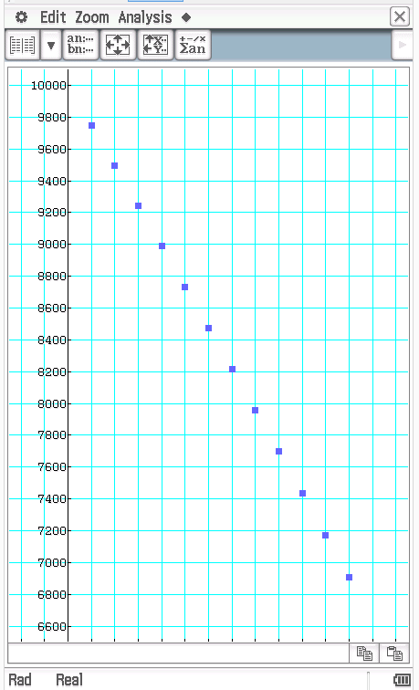Graph C

**Question Two: [3, 1, 3, 2, 2: 11 marks]**

Hayes doesn’t enjoy flying on commercial airplanes anymore and decides that he would like to purchase his own plane. He has a lot of money but needs to borrow some money from the bank in order to fund the purchase.

He borrows $200 000 and decides to make regular monthly repayments.

The following table shows the balance of the loan and the amount of interest for the first three months.

|  |  |  |  |
| --- | --- | --- | --- |
| Month | Balance at the start of the month | Interest | Balance at the end of the month |
| 1 | 200 000 | 750 | 199 250 |
| 2 | 199 250 | 747.19 | 198 497.19 |
| 3 | 198 497.19 | 744.37 | 197 741.56 |

a) What is the annual interest rate on this loan?

b) How much is Hayes repaying each month?

c) Give the recurrence formula to calculate the balance at the start of each month.

d) How much is owing on this loan at the end of the first 12 month?

e) How much interest has been paid in the first 12 months of the loan?

**Question Three: [2, 2, 2, 3, 1, 1: 11 marks]**

Gordon borrows some money and aims to pay it off in 12 months by making regular monthly repayments. The interest rate he is being charged is 9% p.a compounding monthly.

Consider the following partial table containing details of the loan.

|  |  |  |  |
| --- | --- | --- | --- |
| Month | Balance at the start of the month | Interest | Balance at the end of the month |
| 1 |  | 18.75 | 2318.75 |
| 2 | 2318.75 | 17.39 | 2136.14 |
| 3 |  |  |  |
| … |  |  |  |
|  | 34.75 |  | 0 |

a) How much money did Gordon borrow?

b) How much are the monthly repayments?

c) What is the balance at the end of the 3rd month?

d) How long does it take Gordon to pay off the loan and calculate the total amount of interest Gordon pays?

Gordon wanted to pay the loan off in 12 months.

e) Calculate how much he would need to pay each month if he is to pay the loan off in 12 months.

d) Besides from increasing the repayments, suggest another way Gordon could decrease the time taken to repay the loan.

**Question Four: [5, 3: 8 marks]**

Consider the following information from the ANZ website.

Source: <http://www.anz.com/personal/personal-loans/personal-loans-overview/fixed-rate/>





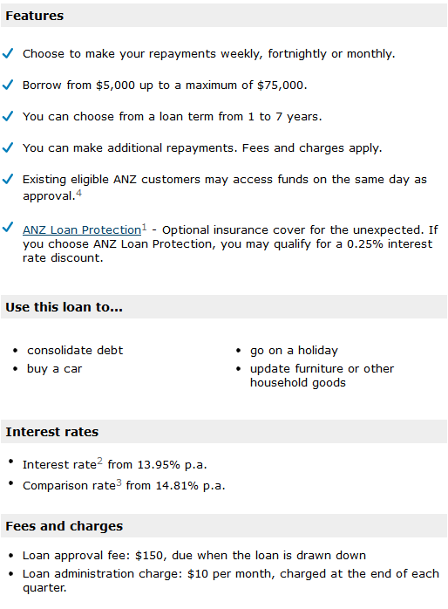

Jaime is considering taking a $23 000 loan from ANZ for 12 months. They have offered him 13.95% p.a. compounding monthly. He has taken ANZ loan protection so the interest rate discount will apply. He is using a table to calculate the total amount of interest, fees and charges he will have paid by the end of the 12 months.

|  |  |  |  |  |  |
| --- | --- | --- | --- | --- | --- |
| Month | Amount Owing at the start of the month | Interest | Repayment | Fees | Amount Owing at the end of the month |
| 1 | 23 000 + (150 loan approval fee) | 264.30 | 2100 | - | 21314.30 |
| 2 | 21314.30 | 243.34 | 2100 | - |  |
| 3 | 19457.64 | 222.14 | 2100 | 30 (monthly admin fee) | 17609.78 |
| 4 | 17609.78 |  | 2100 |  |  |
| 5 |  |  | 2100 |  |  |
| 6 |  |  | 2100 | 30 | 11877.63 |
| 7 |  |  | 2100 |  |  |
| 8 |  |  | 2100 |  |  |
| 9 |  |  | 2100 | 30 |  |
| 10 |  |  | 2100 |  |  |
| 11 |  |  | 2100 |  |  |
| 12 |  |  |  | 30 | 0 |

a) If Jaime wants to pay the loan off fully in 12 months how much does he need to pay in his final repayment (include the final $30 fee in this figure).

b) What is the total amount of interest payable on this loan?

**Question Six: [3, 3, 3: 9 marks]**

Compare the total amount of interest payable and the total time taken to pay off a loan of $10 000 under the following varying conditions.

|  |  |  |  |  |  |
| --- | --- | --- | --- | --- | --- |
|  | Interest Rate | Compounding | Repayments | Total length of time to pay off loan | Total amount of interest payable |
| **A** | 15.95% p.a | Monthly | $160/month |  |  |
| **B** | 15.95% p.a | Monthly | $80/fortnightly |  |  |
| **C** | 15.95% p.a | Monthly | $40/week |  |  |

Use 52 weeks in a year for your calculations.

**Topic: Reducing Balance on Loans SOLUTIONS**

Time: 45 mins Marks: /45 marks

**No calculator allowed**



**Question One: [2, 2, 2: 6 marks]**

Nigella has a loan of $10 000 which is at 5.9% p.a interest compounding monthly. She is making $100 monthly repayments. Nigella is using her calculator to predict the amount she will have owing at the start of each month for the first twelve months. The graph below depicts that.



Consider the graphs on the next page. Each graph depicts the balancing owing on the loan at the start of each month for the first twelve months of the loan.

a) Which of the graphs depict the effect of increasing the repayment to $300 per month on the balance at the start of each month? Estimate the final balance from the graph.

 C $\sim \$6 900$

b) Which of the graphs depict the effect of decreasing the interest rate to 3% p.a but keeping the monthly repayments at $100 per month, on the balance at the start of each month? Estimate the final balance from the graph.

 B $\sim \$9 090$

c) Which of the graphs below depict the effect of decreasing the interest rate to 3% p.a and reducing the monthly repayments to $300 per month, on the balance at the start of each month? Estimate the final balance from the graph. A $\sim \$6 650$

Graph A Graph B

Graph C

**Question Two: [3, 1, 3, 2, 2: 11 marks]**

Hayes doesn’t enjoy flying on commercial airplanes anymore and decides that he would like to purchase his own plane. He has a lot of money but needs to borrow some money from the bank in order to fund the purchase.

He borrows $200 000 and decides to make regular monthly repayments.

The following table shows the balance of the loan and the amount of interest for the first three months.

|  |  |  |  |
| --- | --- | --- | --- |
| Month | Balance at the start of the month | Interest | Balance at the end of the month |
| 1 | 200 000 | 750 | 199 250 |
| 2 | 199 250 | 747.19 | 198 497.19 |
| 3 | 198 497.19 | 744.37 | 197 741.56 |

a) What is the annual interest rate on this loan?



b) How much is Hayes repaying each month?

c) Give the recurrence formula to calculate the balance at the start of each month.

d) How much is owing on this loan at the end of the first 12 month?

e) How much interest has been paid in the first 12 months of the loan?

**Question Three: [2, 2, 2, 3, 1, 1: 11 marks]**

Gordon borrows some money and aims to pay it off in 12 months by making regular monthly repayments. The interest rate he is being charged is 9% p.a compounding monthly.

Consider the following partial table containing details of the loan.

|  |  |  |  |
| --- | --- | --- | --- |
| Month | Balance at the start of the month | Interest | Balance at the end of the month |
| 1 |  | 18.75 | 2318.75 |
| 2 | 2318.75 | 17.39 | 2136.14 |
| 3 |  |  |  |
| … |  |  |  |
|  | 34.75 |  | 0 |

a) How much money did Gordon borrow?

b) How much are the monthly repayments?

c) What is the balance at the end of the 3rd month?

d) How long does it take Gordon to pay off the loan and calculate the total amount of interest Gordon pays?

Gordon wanted to pay the loan off in 12 months.

e) Calculate how much he would need to pay each month if he is to pay the loan off in 12 months.

d) Besides from increasing the repayments, suggest another way Gordon could decrease the time taken to repay the loan.

Instead of monthly repayments, repay $50 each week. Find a bank which offers a lower interest rate.

**Question Four: [5, 3: 8 marks]**

Consider the following information from the ANZ website.

Source: <http://www.anz.com/personal/personal-loans/personal-loans-overview/fixed-rate/>







Jaime is considering taking a $23 000 loan from ANZ for 12 months. They have offered him 13.95% p.a. compounding monthly. He has taken ANZ loan protection so the interest rate discount will apply. He is using a table to calculate the total amount of interest, fees and charges he will have paid by the end of the 12 months.

|  |  |  |  |  |  |
| --- | --- | --- | --- | --- | --- |
| Month | Amount Owing at the start of the month | Interest | Repayment | Fees | Amount Owing at the end of the month |
| 1 | 23 000 + (150 loan approval fee) | 264.30 | 2100 | - | 21314.30 |
| 2 | 21314.30 | 243.34 | 2100 | - |  |
| 3 | 19457.64 | 222.14 | 2100 | 30 (monthly admin fee) | 17609.78 |
| 4 | 17609.78 |  | 2100 |  |  |
| 5 |  |  | 2100 |  |  |
| 6 |  |  | 2100 | 30 | 11877.63 |
| 7 | 11877.63 | 135.60 | 2100 | - | 9913.23 |
| 8 | 9913.23 | 113.18 | 2100 | - | 7926.41 |
| 9 | 7926.41 | 90.49 | 2100 | 30 | 5946.90 |
| 10 | 5946.90 | 67.89 | 2100 | - | 3914.79 |
| 11 | 3914.79 | 44.69 | 2100 | - | 1859.48 |
| 12 | 1859.48 | 21.23 | 1880.71 | 30 | 0 |

a) If Jaime wants to pay the loan off fully in 12 months how much does he need to pay in his final repayment (include the final $30 fee in this figure).



b) What is the total amount of interest payable on this loan?



**Question Six: [3, 3, 3: 9 marks]**

Compare the total amount of interest payable and the total time taken to pay off a loan of $10 000 under the following varying conditions.

|  |  |  |  |  |  |
| --- | --- | --- | --- | --- | --- |
|  | Interest Rate | Compounding | Repayments | Total length of time to pay off loan | Total amount of interest payable |
| **A** | 15.95% p.a | Monthly | $160/month | 135 months | $$134×160+82.84=21 522.84$$ $$Interest=\$11 522.84$$ ($11 523.93 from spreadsheet) |
| **B** | 15.95% p.a | Monthly | $80/fortnightly | 238 fortnights | $$237×80+0.36=\$18 960.36$$ $$Interest=\$8 960.36$$ ($8 960.35 from spreadsheet) |
| **C** | 15.95% p.a | monthly | $40/week | 473 weeks | $$472×40+15.70=\$11 895.70$$ $$Interest=\$8 895.70$$ ($8 895.70 from spreadsheet) |

Use 52 weeks in a year for your calculations.

(Slight variation in answers depending on finance app or spreadsheet due to unequal year/52 week period)